|  |
| --- |
| **TurnQuest Everest Insurance Suite**  **General Insurance System(GIS)**  **Certificates User Manual** |



**25th June 2014**

## CERTIFICATE MODULE

# Define certificate types

* 1. **Certificate Types**: Certificate types are defined on this screen
* Click to define the cert type on the screen below

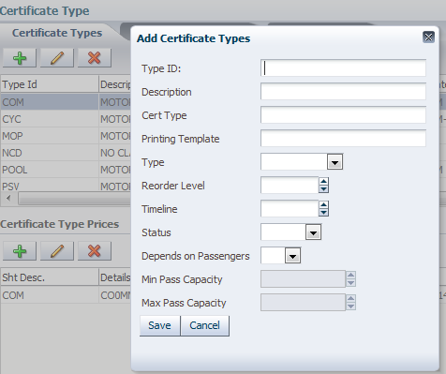

* Click  to the certificate type
* Upon clicking the Save button the details are populated as follows

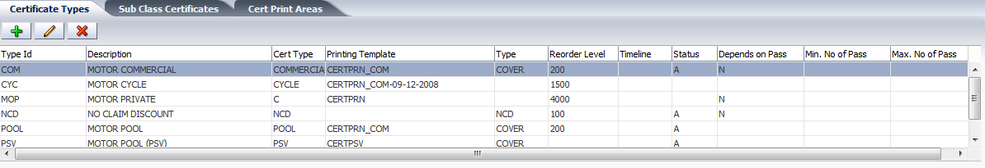

* Once the cert type has been defined, its price would be defined at the **Certificate Type Prices screen**
* **Click** on  to add the amount; this is inclusive of the user who prepared the cert, the cert’s short description and its WEF & WET date.

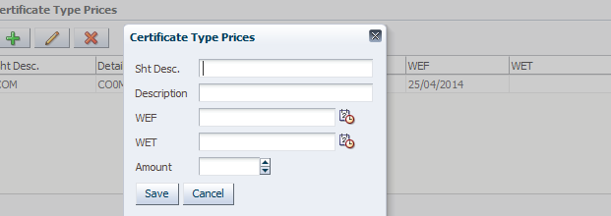

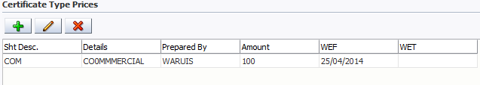

* 1. **Sub Class Certificates**: This is where the certificates attached to a particular subclass are defined.
* Click to select subclass; when successful the code will auto populate

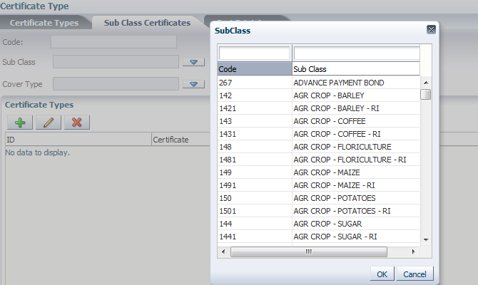

* Click to select the cover type

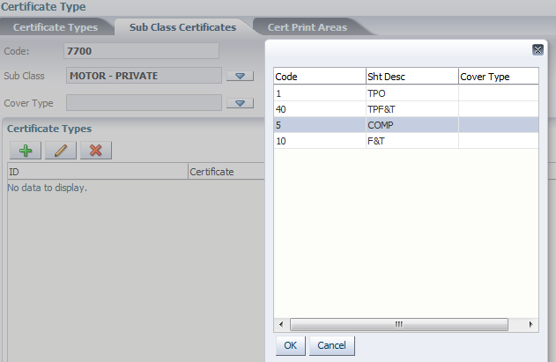

* After choosing the cover type, the certificate types attached to the subclass appear on the lower screen, here, the user will be able to add, edit or delete upon selection of the type.

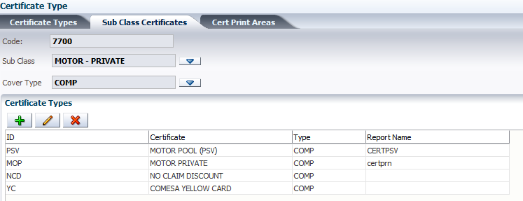

1.3 **Cert Print Areas**: This screen allows the user define the areas(branches) viable for certificate printing.

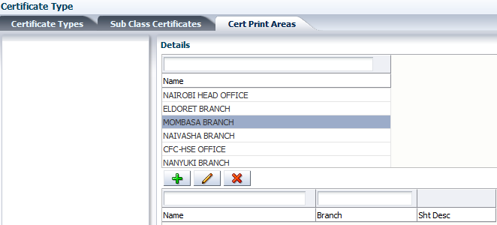

# 2. Certificate type orders

## 2.1 Orders:

* Clickto place an order for a cert type

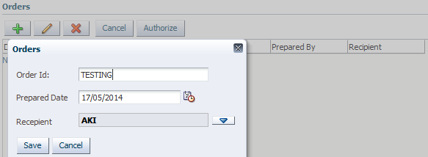

* clickto save the order

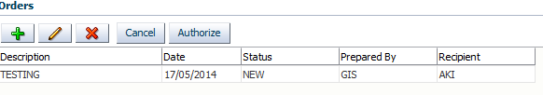

* Select the order details and click the button to authorize the order.

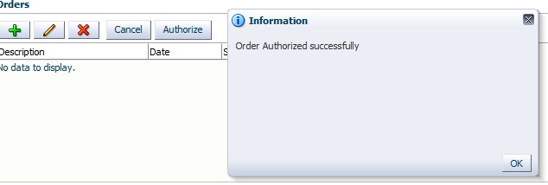

## 2.2 Order Details

* Select the order to fill the order details
* clickand the screen appears as below

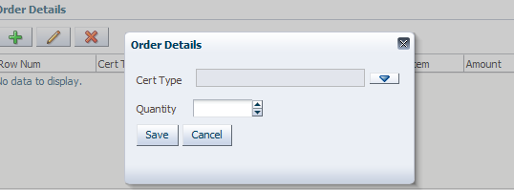

* clickto select the cert type, put in the quantity you want and click

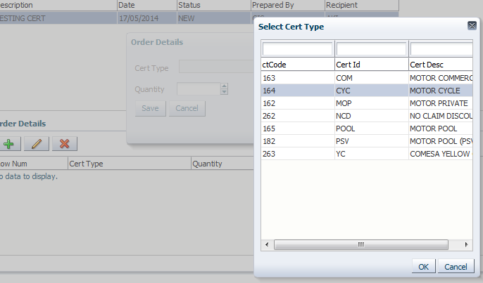

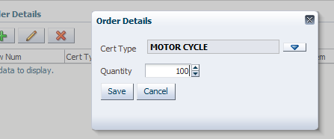

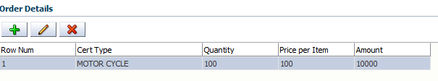

# 3. Cert type payments

Once the order has been successfully authorized, then a certificate requisition can be made.

## 3.1 Payments

* Select the authorized order and check on the select to pay box. Upon checking the amount auto populates.

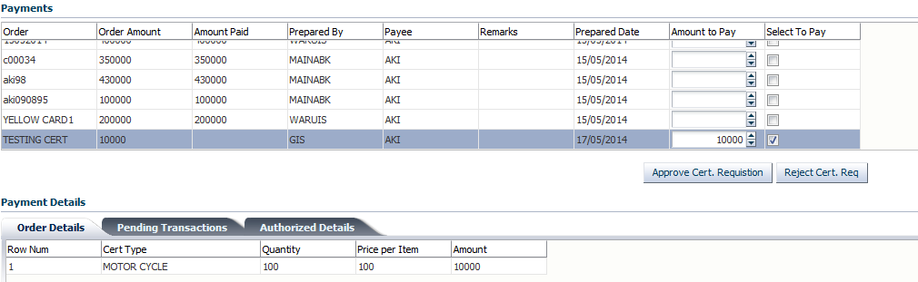

* The “approve the cert requisition” approves the payment while “reject cert req.” button rejects the payment.
* Successful approval of the requisition moves the order to "pending transactions” screen awaiting authorization, the payee being AKI.
  + 1. **Order Details**: The screen shows details of the order being prepared for cert requisition as shown above.
    2. **Pending Transactions**

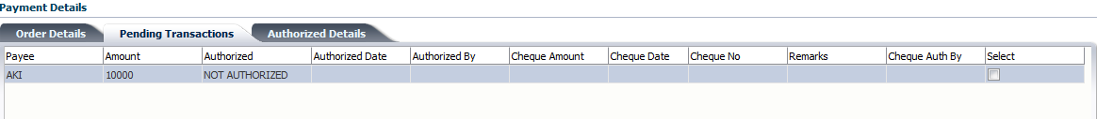

* Check on the select button to make the requisition payment.
  + 1. **Authorized Details**: On successful processing of the requisition, the authorized payment can be seen at the “Authorized Details” screen.
* Select on the order payment and go to the Authorized details screen. The cheque will be processed and authorized at the FMS interface.

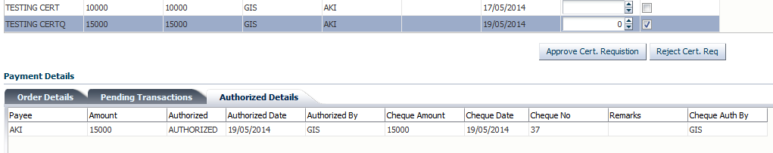

# 4. Cert type deliveries

The delivery process and authorization can begin for certificate type orders that have been successfully paid.

* Click on Certificates >>Cert Type Deliveries

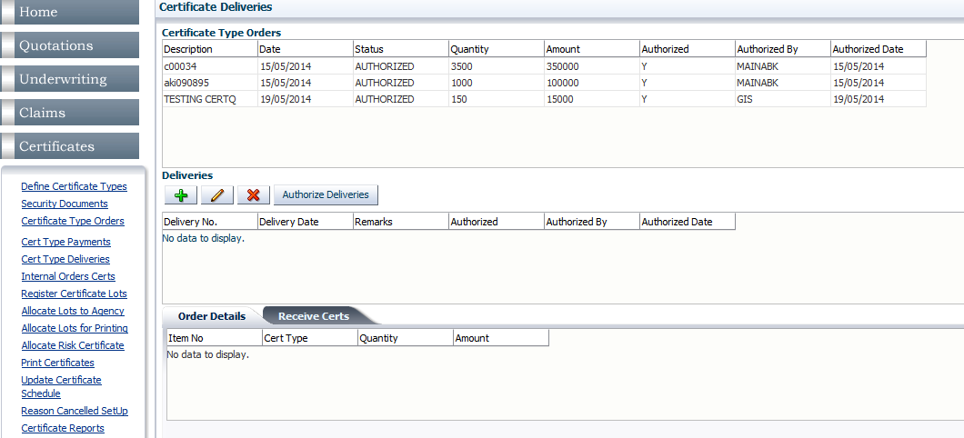

* 1. **Certificate Type Orders:** The table shows orders that have been paid and authorized inclusive of the quantity, amount, authorized by and the date of authorization.

## 4.2 Deliveries

* Select the certificate order to authorize deliveries on the “Deliveries” table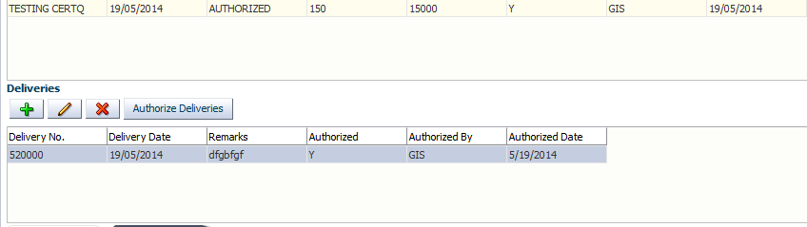
* Click  and the deliveries details appear. The table displays the Delivery no., Delivery date and the remarks

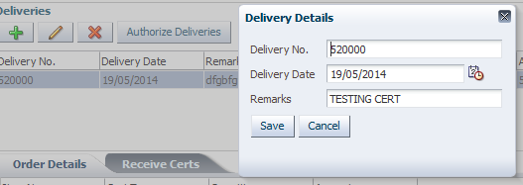

: One cannot manipulate an already authorized delivery.

* clickto authorize deliveries, if successful an information popup appears

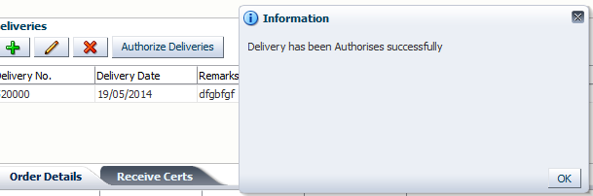

* 1. **Order Details:** On selection of the certificate order delivered displays the order details of the certificate type at the “Order details” tab

## 4.4 Receive Certs

* On the “Receive Certs” tab, select on the certificate detail and clickto view the received certs details

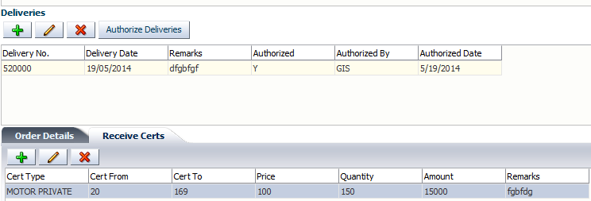

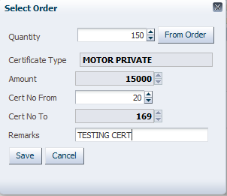

* Quantity shows the amount of certificates ordered
* The button
* The certificate type shows the type of certificate ordered
* The amount paid
* The certificate number from and to

: One cannot manipulate an already authorized delivery.

# 5. Internal orders certs

* Go to Certificates>>Internal Order Certs.
* Clickto make a new internal order.

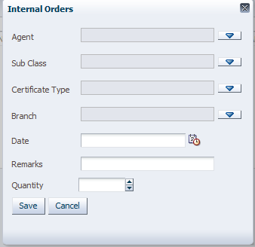

* Click to select on the agent

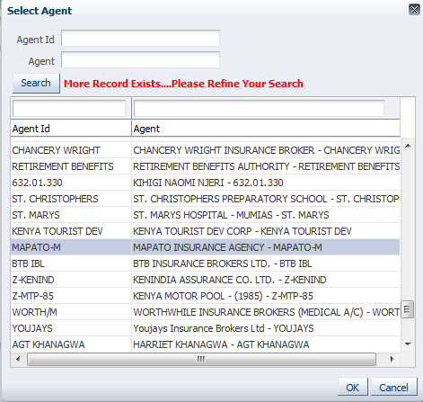

* Click to select on the subclass

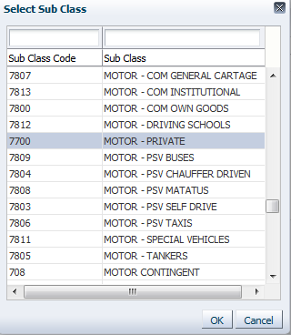

* Click on to select the certificate type

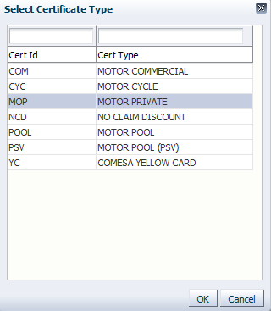

* Click on to select the branch

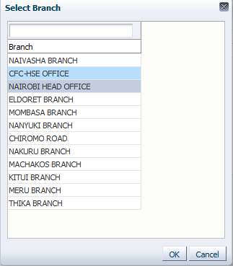

Click to select the order date

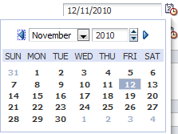

* Add on the remarks
* Add on the quantity to be ordered
* Click to save the order requested

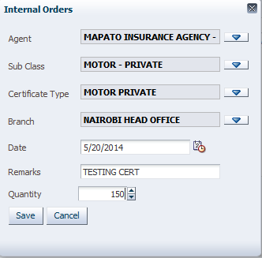

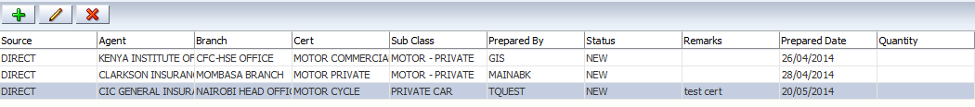

# Certificate Lots from Safe

* 1. **Certificate Lots from Safe**
* Select to choose the source

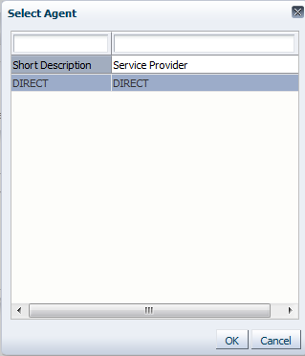

* Select to pick on the certificate type

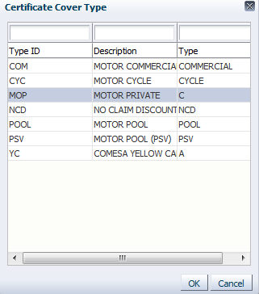

* Click , this will automatically populate the Type ID and the Description

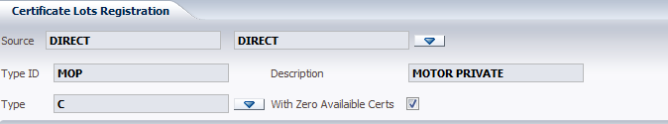

* This in turn brings the lots registered under type C at the “certificate lots” tab

: checking the select box “With Zero Available Certs” gives you the provision to see the certificates that have no available certificates in-safe

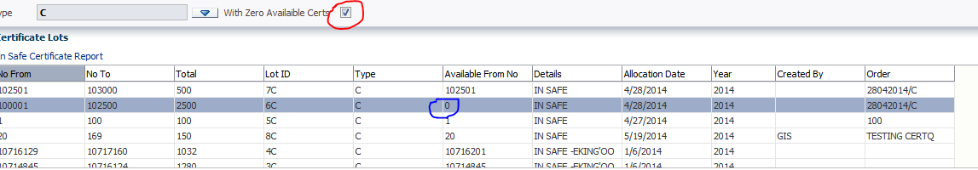

Otherwise, unchecking the box displays the lots with available certificates in-safe

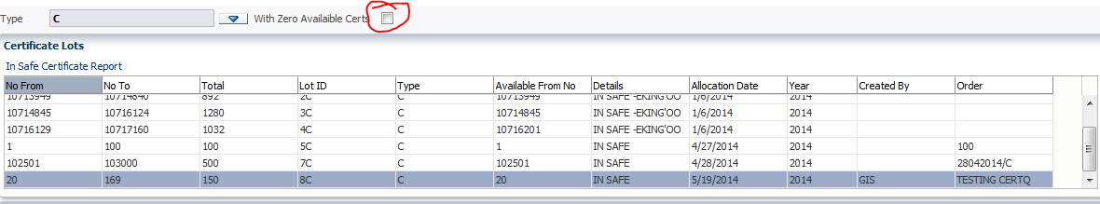

* 1. **Certificate Lots**: This are the certificate lots currently in-safe

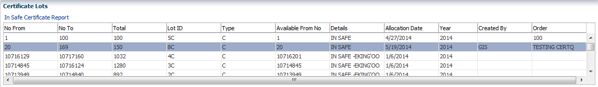

* 1. **Out-of-safe Certificate Lots**: Certificates are moved out-of-safe to be allocated to the respective agencies.
* Select the certificate lot in safe>>Click at the “out of-safe-certs”

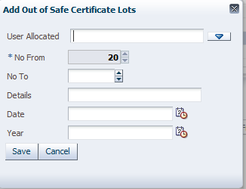

* Click  to select the user allocated and click

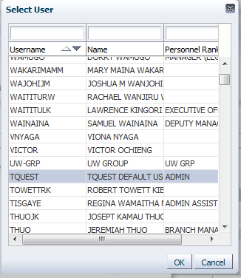

* No. from: Feed in the number of lots to be allocated to the user
* Details
* Date: click to pick the date of certificate movement
* Year: clickto choose the underwriting year
* Click  to save the details.

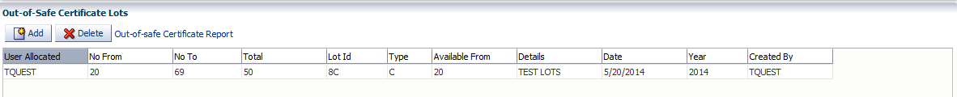

# Allocate lots to agency

This is where certificates are allocated to intermediaries.

## 7.1 Select Certificate Type

* Click to select the certificate type, from “DIRECT”, a dropdown appears displaying the cert types.

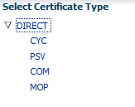

## 7.2 Certificate Lots

* At certificate lots, click on the lot to be allocated.

## 7.3 View Allocated Certificates

* selectto allocate lots to agency at “View Allocated Certificates”

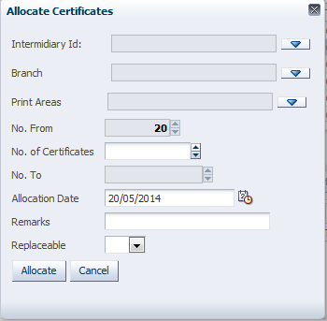

* Click to select the intermediary.

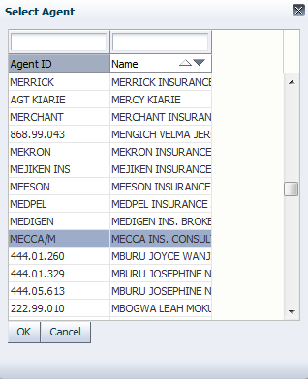

* Click to select on the branch

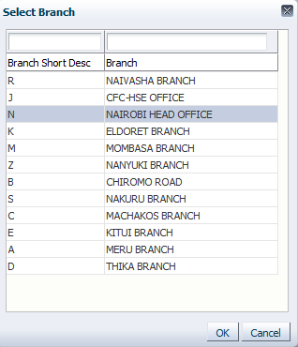

* Click  to select the printing areas
* Type in the No. of Certificates.

: putting in the number of certificates automatically populates the “No. To”.

* Select to select the date of allocation
* Type in the Remarks
* Click on the dropdown button at to select if allocation is replaceable or not.

: If NO, it means the lot allocated cannot be replaced for that particular order, if yes, then one can reorder with proof that the previous lot is exhausted.

* Clickto finish allocation.

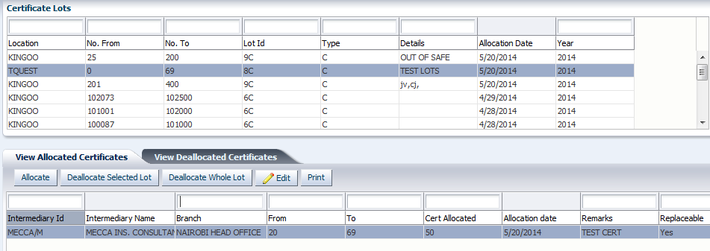

* One can also de-allocate a selected/ a whole lot:
* Click to de-allocate selected lot or click to de-allocate whole
* A Remark screen appears, fill in the reason for de-allocation and then click

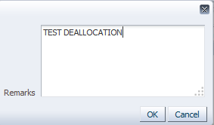

One can also return allocated certificates:

* Click to edit on the selected lot

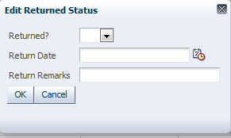

* Click to check if the lots are returned or not
* Click to select on the Return Date
* Add on the return remarks and click.
* On successful return the information box appears as below

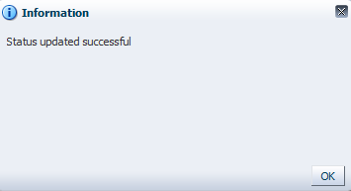

## 7.4 View DE allocated certificates

* The tab shows the lots that have been de-allocated

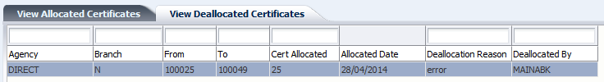

## 7.5 Allocate Certificates for Printing

* Click to select the source
* Click to select the agency branch
* Click to select the description of the certificate.

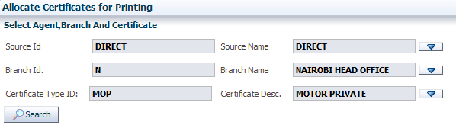

* Click to populate the certificates available for printing under the certificate type.

## 7.7 Certificates Available

: checking the buttonshows lots with available certs, otherwise even the ones without available certificates will be populated.

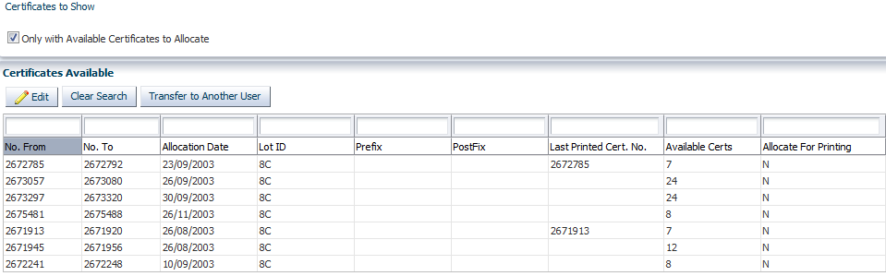

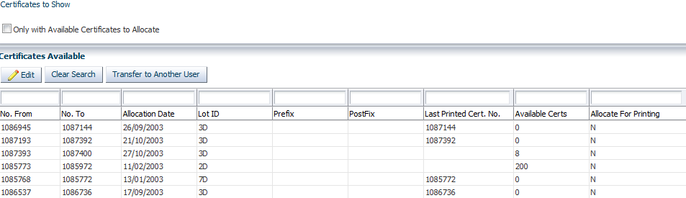

* Select the certificate to be allocated
* clickto allocate

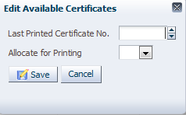

* Enter the Last printed certificate no.
* Click to select “yes” to allocate for printing.

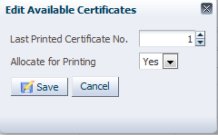

* Click. Successful allocation gives the information popup

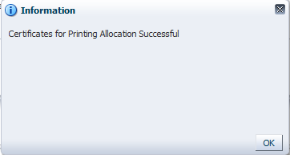

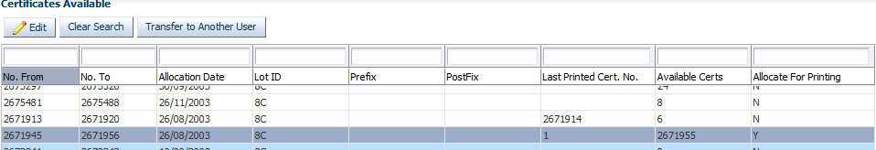

* To refresh the screen to choose another certificate type for allocation.
* to allocate certificates to another user

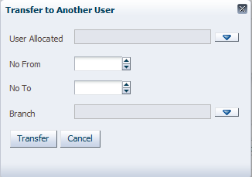

* Click to select user allocated
* Enter the number of certificates to allocate(No.From–No.To)
* Click  to select branch

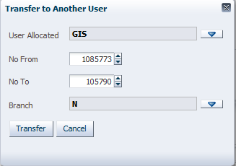

* Clickto transfer to other user.

## 7.8 Allocate risk certificate

This screen provided the ability to attach a risk to a queue for risks certificate printing

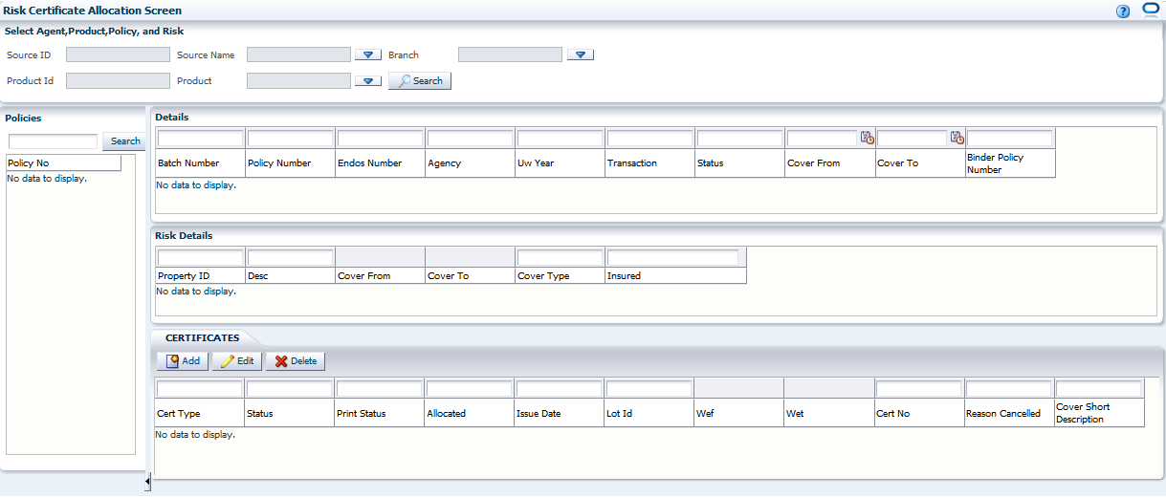

* Click  to select the certificate source
* Click to select the branch – for which the policy was generated in
* Click to select the product for which the risk should be allocated a certificate.

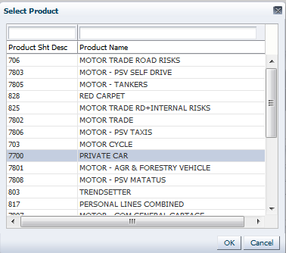

* Click to populate the policies under product specified.

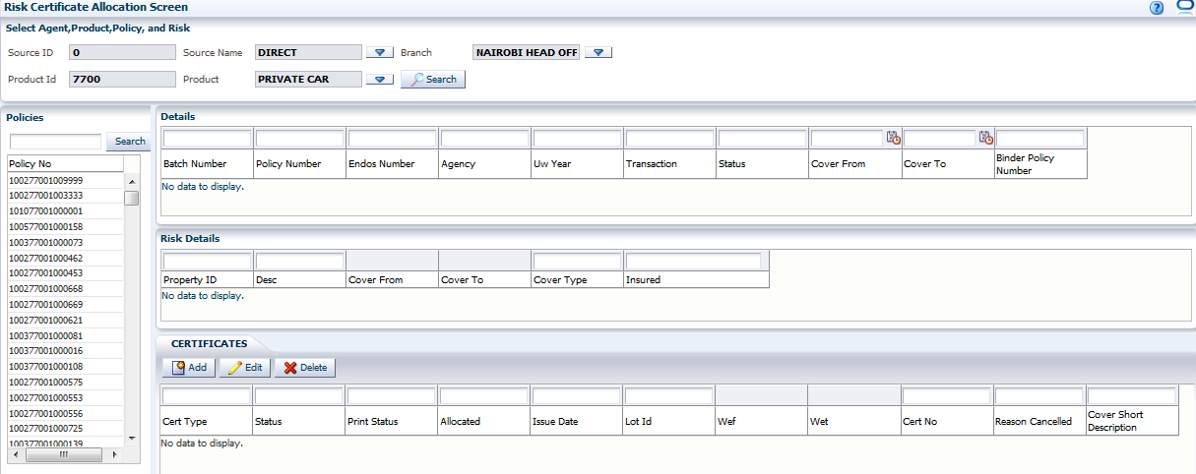

* Select the policy for which you want to allocate a certificate. The policy selected will display its details on the Details table

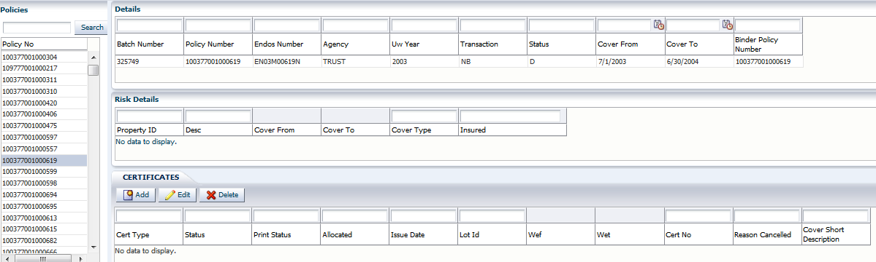

* Select on the policy details to populate the risk details

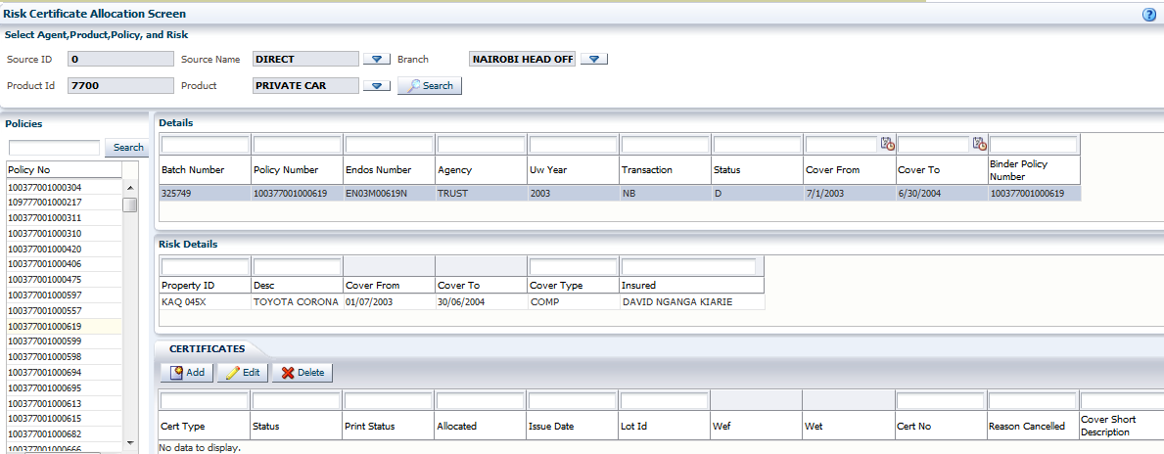

* Select the risk to add, edit or delete the certificate(s).
* Click to add a certificate.

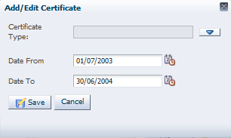

* Click  to select certificate type and click

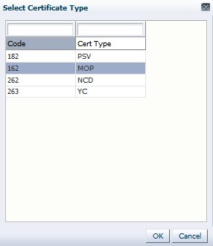

: The date from and date to automatically populate from the risk cover dates. It also provides ability to have a one month certificate.

* Click  to add the certificate to the risk.

One can also edit the certificate allocated to the risk

* Click button.

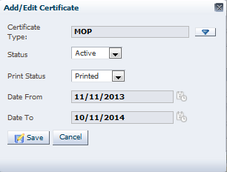

Select on the field you want to edit and save.

: When you edit Status and select on “cancelled”, a popup appears to select reasons for cancellation. After selecting the reason click. The date cancelled would auto-populate and will not be editable.

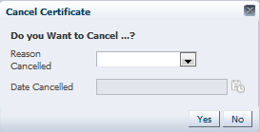

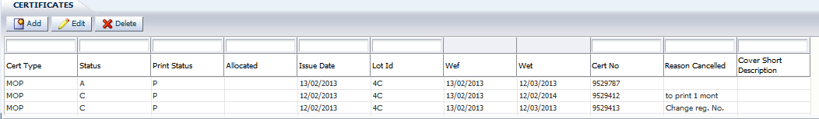

: One will only be able to delete a certificate before allocation of a certificate number; otherwise, attempting to delete a certificate already allocated successfully would bring the error. The correct procedure is to cancel the allocation and state the reason for cancellation and do a fresh allocation.

# Print certificates

* 1. Once a risk is assigned a certificate type in readiness for printing then the certificate can then be printed form this screen.

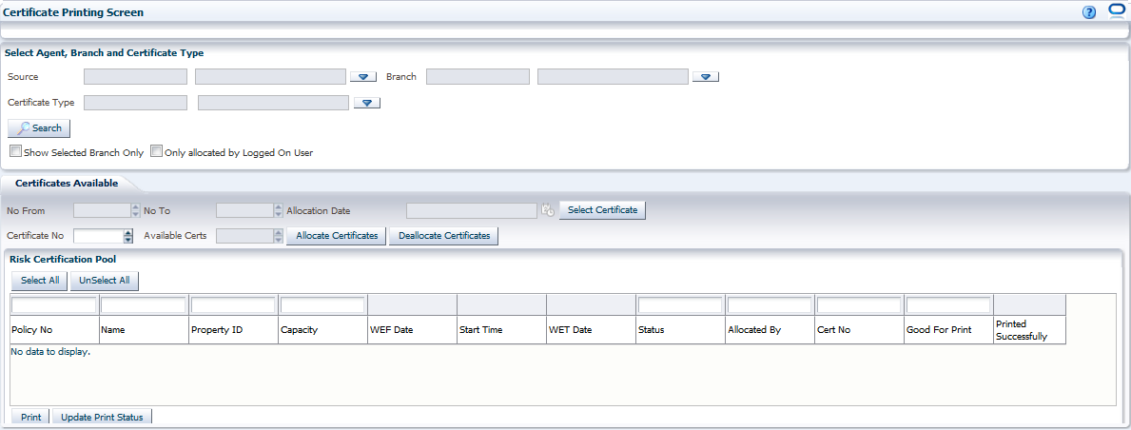

* Go to Certificates>>Print Certificates
* Click to select the source
* Click to select the branch – Select the user branch to provide the available lots in the users default branch
* Click to select the certificate type
* Click to populate the available certificates for printing under the chosen branch for the selected cert type.

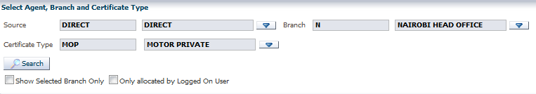

: Checking the box for “Show Selected Branch Only” displays the certificate lots available for the branch specified. Likewise, checking the box “Only allocated by Logged on User” will display the certificate lots allocated for the user currently logged on.

* Click to select the certificate lots allocated for printing under that certificate type. Select the lot and click ok.

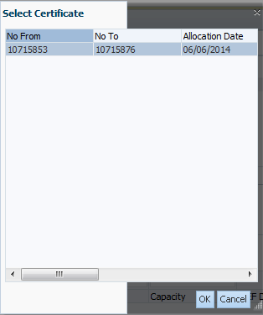

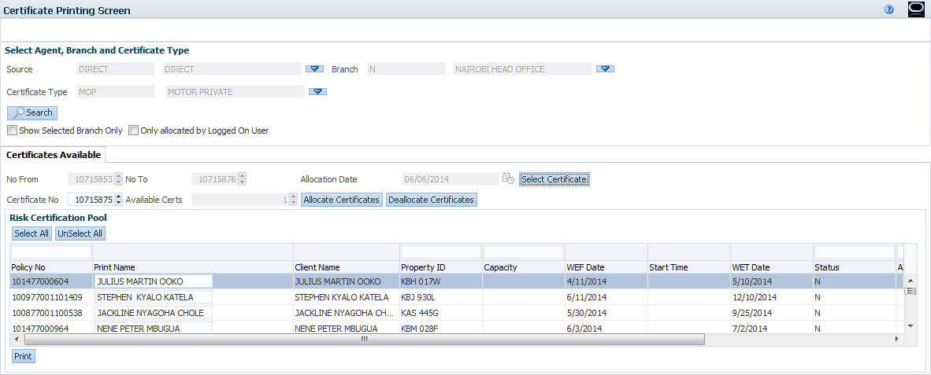

## 8.1 Certificates Available

The section displays the details of the lots to be allocated for printing; this is inclusive of the certificate number available for printing, the current certificate number and the remaining certificates available.

## 8.2 Risk Certificate Pool

* At this point, the user can select all certificates and allocate them for printing.
* Click  to select all the policies whose risks are good for print, otherwise if only one certificate is to be printed, check on the box at the “good for print” column.

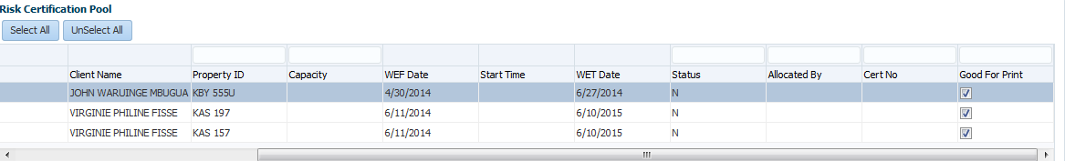

* Click to allocate certificate numbers for the risks. The certificate number allocated will populate sequentially on “Cert No.” column for the risks selected.

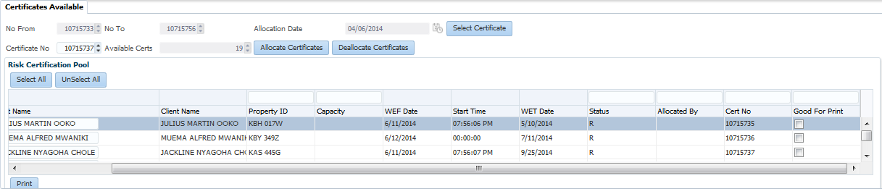

* At this point the user can chose to print all certificates allocated whereby he will click the button and the click, otherwise he can check on the box at the “good for print” column to print individually.
* Select the risk to print a certificate at the check box at the “good for print” column and click.

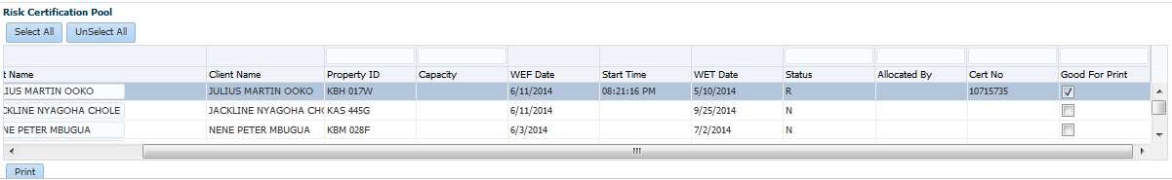

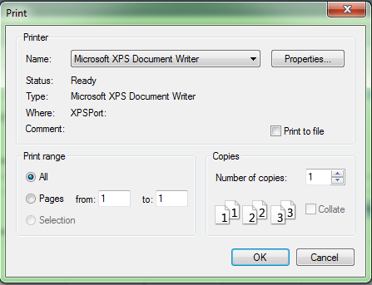

: One can deallocate a certificate for erroneous allocation for instance. Deallocating a certificate would remove a risk from being allocated a certificate number and thus not legible for printing.

* Select the risks to deallocate on the “good for print” check box

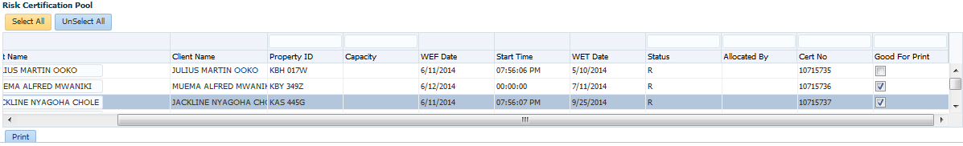

* Click to deallocate selected certificates.

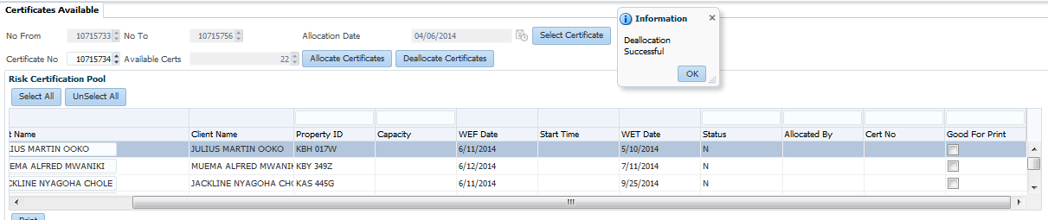

## 8.3 Update certificate schedule

The system allows the user to update the certificates schedule

* Clickto select the source
* Click to select the product
* Click to select the branch
* Click on to search for the available certificates to appear at the allocate lots screen.

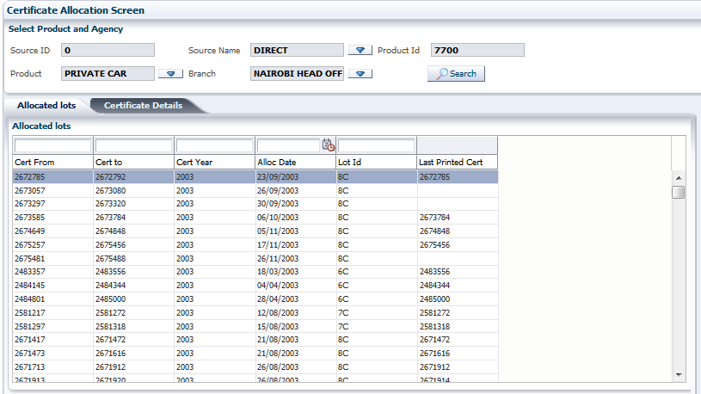

* At the allocated lots screen, select the lot to be updated and click on the Certificate Details.

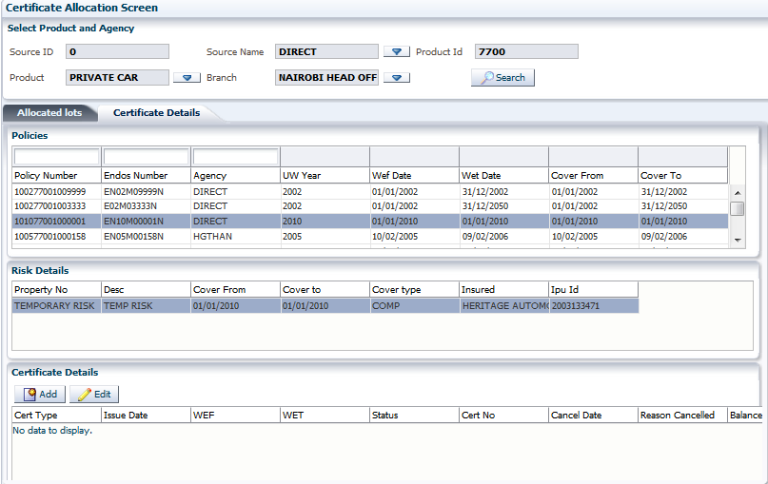

* The policies table displays all the policies under the lot selected.
* Select the policy number to display its risk details
* Select the policy’s risk details to add or edit the certificate(s) if any.
* Click to certificate.

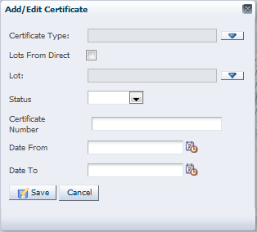

* Click to select certificate type
* Check the “Lots From Direct” box to pick the source from direct
* Click to select the Lot
* Click on the dropdown button to select the status as active, cancelled or inactive.
* Enter the certificate number
* Enter the “date from” and “date to”
* Click  to add the certificate.

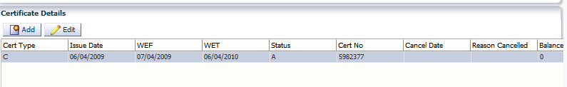

* The Edit button brings you to the certificate screen as below
* Select the certificate and Click to edit.

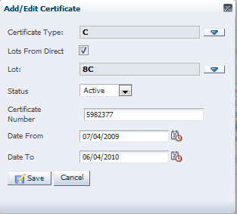

Edit the certificate and click on 

## 8**.4 Reason cancelled setup**

The reasons for certificates cancelation are added and edited on this screen as they will appear at transaction level

* Click  to bring screen for adding/editing the reason(s).

